Job Profile
Position Details
Post | Programme Coordinator – Connected Communities
Service Area | Strategy & Communications Directorate
Reports to | Programme Lead – Connected Communities
Grade | PO3
Job Family | To be completed by HR

Role Purpose
- The post holder will provide excellent project management support to the new Connected Communities programme, leading key aspects of the work and working with the Programme Lead to oversee the effective design, delivery, governance and evaluation of the overall programme.
- The role of the Programme Coordinator is to support the successful introduction of a joined up approach to helping new migrants to settle in the borough, through the successful delivery of the Connected Communities programme and its legacy.
- A key part of the role will be to help ensure that the Programme is more than a sum of its parts, including through building and sustaining a coherent Programme team, across the different services involved in its delivery. This will include training project team members and wider frontline staff and developing high quality resources to support and communicate the aims of the programme.
- The coordinator will help to ensure that the programme has lasting impact beyond the life of the programme; through embedding the learning from the programme across wider policy and sharing experiences with others.

Main Responsibilities
The Project Coordinator will:
- Work with the Programme Manager to design and coordinate the successful delivery of a complex programme ‘Connected Communities’ in line with outcomes agreed with Senior Leadership and central government.
- Assist the Programme Lead in the design and set up phase of the programme, including commissioning external organisations, building up networks and supporting new frontline staff, as appropriate.
- Build and support the programme network to deliver high quality, sustainable and value for money projects that are delivered on time, on budget, to meet council priorities and the programme’s objectives.
- Develop and deliver of training and resources; designing and producing high quality Information, Advice and Guidance materials for new migrants, frontline staff and other Council officers and partners, (working with the Programme Lead).
- Deliver training and information sessions to frontline staff across the Council and its partners; and facilitate a good practice sharing network, working with the Programme Lead.
- Use excellent programme management to monitor performance across the five strands of the programme: flagging and monitoring risks; identifying emerging issues and developing solutions; making links with broader Council initiatives; and evaluating the programme’s impact.
- Support governance and evaluation of the programme, including the Programme Steering Group and the relationship between the programme and the Ministry of Housing, Community and Local Government.
- Assist in the development of strategic, co-ordinated approaches to support individuals and families with a wide range of needs, and help to embed the learning system-wide.
- Embed sustainability into decisions made on the programme, including strengthening links between Haringey services, and between Haringey services, public services and the voluntary and community sector (VCS).
- Draw out wider policy lessons and embed these within wider Council Policy and service design.
- Build and maintain excellent stakeholder relationships, including the forging of strong relationships between the programme and external partners working with migrants within public services (e.g. health services, employers and the Voluntary Community Sector, and sharing knowledge and good practice with other local authorities.

Generic Responsibilities
- Understanding, knowledge and ability to follow guidelines that ensures compliance with Health and Safety at Work, Data Protection and other statutory requirements.
- Maintain a safe and healthy working environment and ensure that the Council’s policies in this area are adhered to.
- Maintain a good working knowledge of the Council’s functions and processes and keep up to date with changes.
- Knowledge and experience of using IT.
- To undertake any other temporary responsibilities aligned with the overall purpose and grade of the role.

Person Specification

The Person

To carry out the role effectively you will need to be a proactive and experienced project manager who understands the link between the strategic aims of an organisation and the delivery of successful projects.

Knowledge, Qualifications, Skills and Experience | Essential or  Desirable
Abilities/Experiences  - Experience of managing projects in a public sector environment, including drafting business cases, project briefs and other project documentation.  - A recognised qualification in project management, such as, the APMP Project Management Qualification.  - Ability and experience of developing strong working relationships across the organization and its partners.  - Ability to prioritise and manage the workload of the team effectively in a busy environment.  - Experience of working directly with senior officers and Councillors and working in a complex, politically-led environment.  - Ability to work effectively as part of a fast-paced, multi-disciplinary team and to build strong, supportive relationships with colleagues.  - Proven ability to innovate and develop ideas and concepts into practice, with experience in delivering new ways of working.  - Able to stay abreast of new developments, tools and techniques relevant to the function and the capability to communicate and deploy these is an appropriate, effective way.  - Experience of training frontline staff and community organisations and of producing advice and guidance materials.  - Ability to work flexibly and pragmatically, taking an agile approach to the programme and responding to new developments in an open manner.  Qualifications (only if applicable)  - Educated to degree level.  - Project management qualification  Knowledge/Skills  - Comfortable working in a fast-paced, changeable environment with the ability to respond quickly and appropriately to new challenges.  - Knowledge and understanding of equality issues in relation to service provision.  - Background in social policy and of migration and integration issues in particular.  - Highly developed written/oral communication skills.  - Demonstrable experience of research and analysis, project management, and policy briefings in either the public or private sector – ability to produce complex, high quality reports and analysis for senior officers and Cabinet.  - Knowledge and experience of project planning and management. | Essential  Desirable  Essential  Essential  Desirable  Essential  Essential  Essential  Desirable  Essential  Desirable  Desirable  Essential  Desirable  Desirable  Essential  Desirable  Essential

Main Contacts & Other Information
Main Contacts:

- Connected Communities Programme Lead
- Head of Policy & Cabinet Support
- Connected Communities Programme Steering Group and frontline staff
- Assistant Director of Strategy & Communications
- SLT and Corporate Management Group
- Leader and Cabinet Members
- Key external partners and stakeholders, including VCS

Organisational Structure
Note that this post will also work closely with up to 15 staff working across different services on the delivery of the Programme, in a matrix structure.
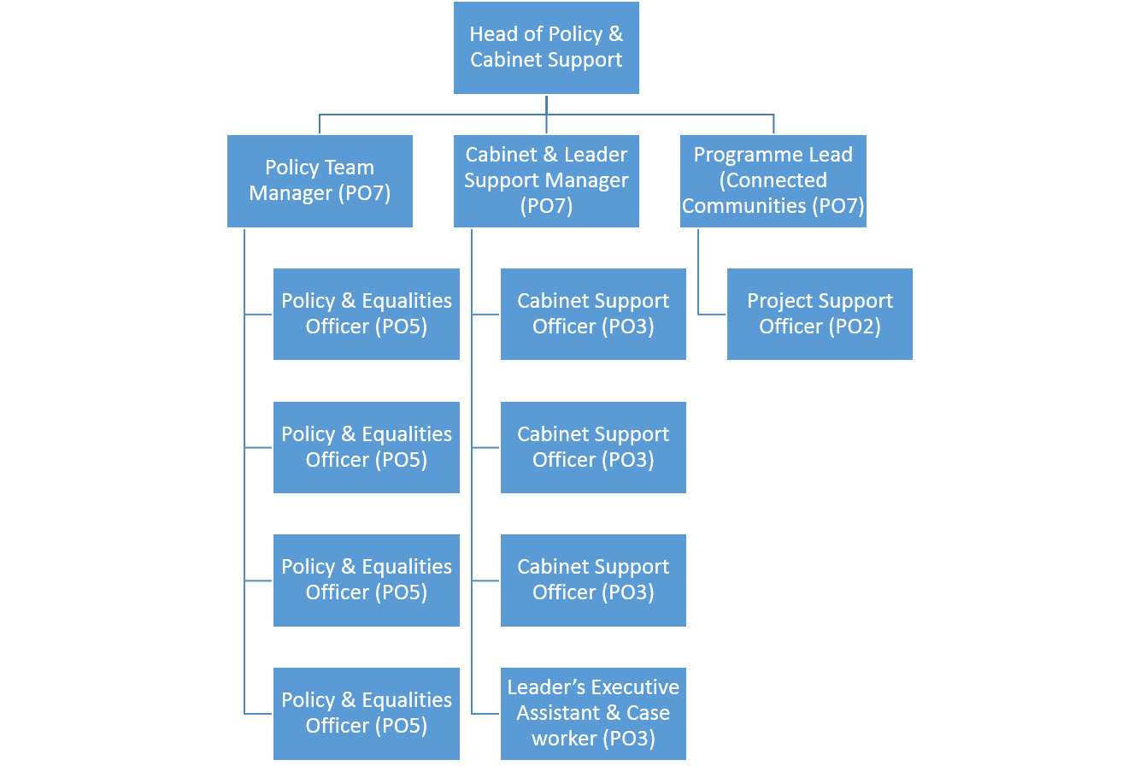

Additional Information

Please complete the additional information as fully as you can.

Supervision / Management of People
Please indicate which group best describes the total number of staff the post holder is responsible for:
None | Up to 5 staff | 6 to 15 staff | 16 to 49 staff | 50 plus staff
X
Are the staff based at the same work location? |  |  |  | Yes/No
Will the post holder be responsible for contract / agency / project staff? |  |  |  | Yes/No

In the normal course of their duties would it be reasonable to expect the job holder to undertake, or be involved in, any of the following on a regular basis.
If Yes, please provide an estimate of the % of their working day this involves.

Work Environment
Activity | Yes/No | % of working day | Activity | Yes/No | % of working day
Office duties. | Yes | 80% | Use of a computer. | Yes | 60%
Audio typing. |  |  | Crisis or conflict situations.
Walking more than a mile. |  |  | Manual handling.
Working alone or in isolation. | Yes | 30% | Working in confined spaces.
Driving a car, van or minibus. |  |  | Preparing or serving food.
Exposure to infectious diseases, e.g. Tuberculosis (TB) or Hepatitis B. |  |  | Working in awkward positions, e.g. stooping, bending, reaching.
Exposure to substances hazardous to health, including lead, asbestos or radioactive substances. |  |  | Operating heavy or hazardous machinery including forklifts, diggers or cranes.
Regular and repetitive movements. |  |  | Working shifts / unsocial hours, nights. | Rarely | 2%
Outdoor work involving uneven surfaces. |  |  | Standing or sitting for prolonged periods. | Yes | 75%

Activity | Yes/No | % of working day | Activity | Yes/No | % of working day
Working shifts / unsocial hours / nights. |  |  | Working at heights / on ladders, roof work.
Teaching, or responsibility for, children. |  |  | Outdoor work involving extremes of temperature.
Electrical hazards. |  |  | Control and restraint.

Resources – identify & list personal and identifiable accountability for physical and financial resources including those of clients:
IT equipment; resources allocated to specific projects as directed by the team manager

Cash/Financial Resources - Is the post personally and identifiably accountable for the accurate handling / security of cash and cheques? If yes, specify the average amount controlled at any one time and the nature of the accountability:
No

Plant/Equipment - is the post personally accountable for the proper use / safekeeping of plant / equipment? If yes, please indicate the type(s) of plant/equipment and the nature of the accountability:
No

Stocks/Materials - Is the post personally accountable for materials / items of stock? If yes, please indicate the type and approximate value and the nature of accountability:
No

Data Systems - is the post personally accountable for the use, manipulation and safekeeping of data systems whether manual or computerised? If yes please indicate the type of system(s) and the nature of the accountability, whilst explaining the importance of the data systems to the Council’s operations:
Yes – maintaining, updating and analysing project plans and data will be a key element of the role.

Buildings - Is the post personally accountable for the proper use and safekeeping of buildings? If yes please indicate the type of building(s) concerned and the nature of the accountability:

No

