Job Profile
Position Details
Post | Connected Communities Lead
Service Area | Strategy & Communications Directorate
Reports to | Rebecca Hatch, Head of Policy & Cabinet Support
Grade | PO7
Job Family | To be completed by HR

Role Purpose
- The post holder will provide leadership and excellent programme management to the new Connected Communities programme; overseeing all strands of the programme and taking overall responsibility for its effective design, delivery and governance.
- The role of the Programme lead is to ensure that Haringey develops a joined up approach to helping new migrants to settle in the borough, through the successful delivery of the Connected Communities programme and its legacy.
- The key purpose of the role will be to make sure that the Programme is more than a sum of its parts, including through building and sustaining a coherent Programme team and stakeholder network, across the different services and partner organisations involved in its delivery.
- The manager will ensure that the programme has lasting impact beyond the life of the programme; through embedding the learning from the programme across wider policy and sharing experiences with others.

Main Responsibilities
The Programme Lead will:
- Manage and be responsible for the successful delivery of the ambitious ‘Connected Communities’ programme, in line with outcomes agreed with Senior Leadership and MHCLG. The Senior Programme Manager will lead a multi-agency team to deliver high quality interventions that are delivered on time, on budget, to meet the programme’s objectives and wider Council priorities.

- Manage the five strands of the programme, through a matrix approach. The Manager will be directly responsible for the project coordinator and will have a dotted line to 15 project staff working across Housing, Employment, Children’s Services and the VCS. A key challenge of the role will be in building up a strong team spirit across staff working in different service areas.

- Develop a strong partnership approach to the programme, including taking responsibility for the forging of strong relationships between the programme and external partners working with migrants within public services (e.g. health services, employers and the Voluntary Community Sector, and sharing knowledge and good practice with other local authorities.
- Develop and manage strategic, co-ordinated approaches to support individuals and families with a wide range of needs, and embed the learning system-wide.
- Embed sustainability into decisions made on the programme, including strengthening links between Haringey services, and between Haringey services, public services and the VCS.

- Draw out wider policy lessons and embed these within wider Council Policy and service design.
- Design and produce high quality Information, Advice and Guidance materials for new migrants, frontline staff and other Council officers and partners.
- Deliver training and information sessions to frontline staff across the Council and its partners and to facilitate a good practice sharing network.

- Manage the Programme Steering Group and effective governance of the Programme. Manage evaluation of the programme, including the Programme Steering Group and the relationship between the programme and the Ministry of Housing, Community and Local Government.

- Work closely with relevant Heads of Service to set up the programme effectively, including adapting the programme design, commissioning external partners and training new staff, as appropriate.

Generic Responsibilities
- Understanding, knowledge and ability to follow guidelines that ensures compliance with Health and Safety at Work, Data Protection and other statutory requirements.
- Maintain a safe and healthy working environment and ensure that the Council’s policies in this area are adhered to.
- Maintain a good working knowledge of the Council’s functions and processes and keep up to date with changes.
- Knowledge and experience of using IT.
- To undertake any other temporary responsibilities aligned with the overall purpose and grade of the role.

Knowledge, Qualifications, Skills and Experience | Essential or  Desirable
Abilities/Experiences  - Experience of managing projects in a public sector environment, including drafting business cases, project briefs and other project documentation.  - A recognised qualification in project management, such as, the APMP Project Management Qualification.  - Experience of working effectively with a wide range of multi-disciplinary teams, senior managers and partner organisations.  - Ability to prioritise and manage the workload of the team effectively in a busy environment.  - Experience of working directly with senior officers and Councillors and working in a complex, politically-led environment.  - Ability and experience of developing strong working relationships with diverse stakeholders, at differing levels of seniority.  - Experience of building and nurturing a high performing team.  - Ability to brief and advise the corporate and political leadership teams and equivalents, face to face, confidently, concisely and clearly and deal with their questions.  - Proven ability to innovate and develop ideas and concepts into practice, with experience in policy and strategy development at a project manager level.  - Able to stay abreast of new developments, tools and techniques relevant to the function and the capability to communicate and deploy these is an appropriate, effective way.  Qualifications (only if applicable)  - Educated to degree level.  - Project management qualification  Knowledge/Skills  - Comfortable working in a fast-paced, changeable environment with the ability to respond quickly and appropriately to new challenges.  - Knowledge and understanding of equality issues in relation to service provision.  - Background in social policy and of migration and integration issues in particular.  - Highly developed written/oral communication skills.  - Demonstrable experience of research and analysis, project management, and policy briefings in either the public or private sector – ability to produce complex, high quality reports and analysis for senior officers and Cabinet.  - Knowledge and experience of project planning and management.  - Knowledge of qualitative and quantitative research methods and first rate analysis skills. | Essential  Desirable  Essential  Essential  Essential  Essential  Essential  Essential  Essential  Essential  Essential  Desirable  Essential  Essential  Essential  Essential  Essential  Essential  Essential

Main Contacts & Other Information
Main Contacts:

- Head of Policy & Cabinet Support
- Programme Steering Group and frontline staff
- Assistant Director of Strategy & Communications
- SLT and Corporate Management Group
- Leader and Cabinet Members
- Key external partners and stakeholders, including VCS

Organisational Structure
Note that this post will also have dotted line management over up to 13 staff working across different services on the delivery of the Programme. 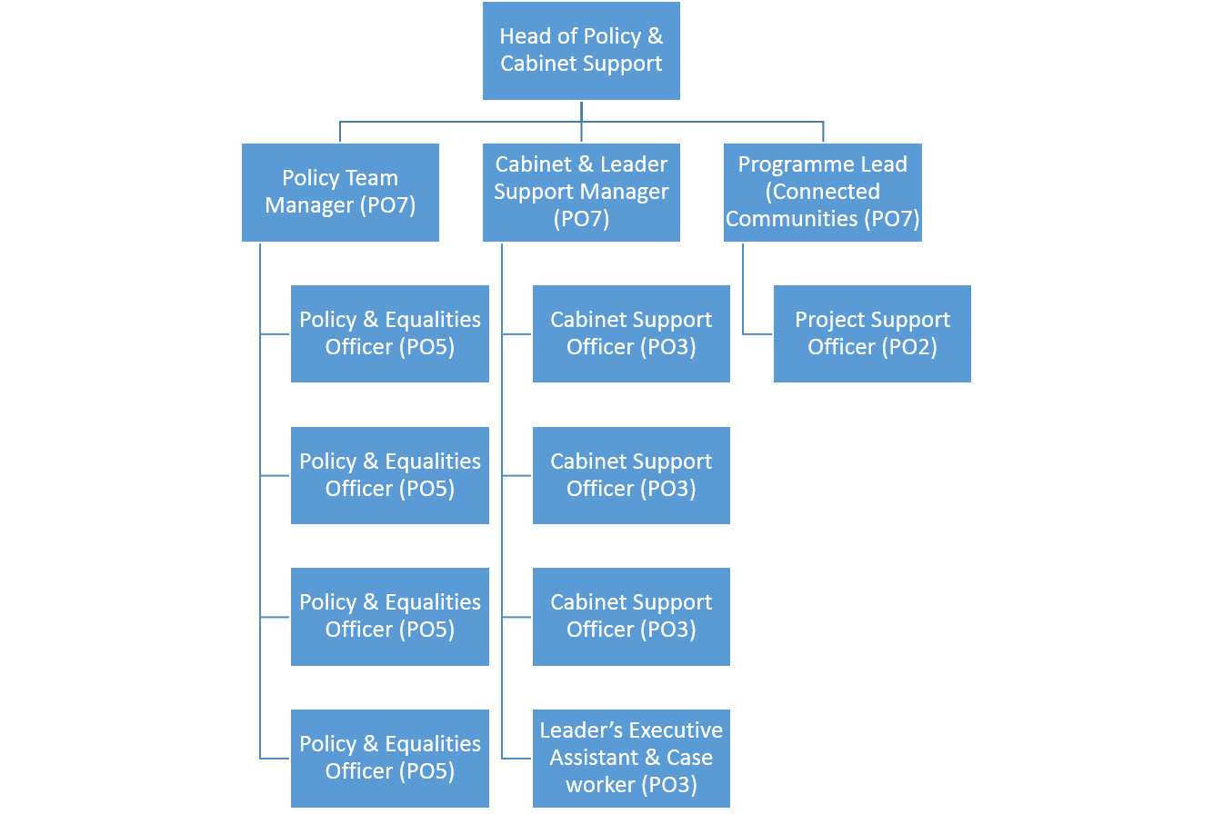

Additional Information

Please complete the additional information as fully as you can.

Supervision / Management of People
Please indicate which group best describes the total number of staff the post holder is responsible for:
None | Up to 5 staff | 6 to 15 staff | 16 to 49 staff | 50 plus staff
 | X
Are the staff based at the same work location? |  |  |  | Yes/No
Will the post holder be responsible for contract / agency / project staff? |  |  |  | Yes/No

In the normal course of their duties would it be reasonable to expect the job holder to undertake, or be involved in, any of the following on a regular basis.
If Yes, please provide an estimate of the % of their working day this involves.

Work Environment
Activity | Yes/No | % of working day | Activity | Yes/No | % of working day
Office duties. | Yes | 80% | Use of a computer. | Yes | 60%
Audio typing. |  |  | Crisis or conflict situations.
Walking more than a mile. |  |  | Manual handling.
Working alone or in isolation. | Yes | 30% | Working in confined spaces.
Driving a car, van or minibus. |  |  | Preparing or serving food.
Exposure to infectious diseases, e.g. Tuberculosis (TB) or Hepatitis B. |  |  | Working in awkward positions, e.g. stooping, bending, reaching.
Exposure to substances hazardous to health, including lead, asbestos or radioactive substances. |  |  | Operating heavy or hazardous machinery including forklifts, diggers or cranes.
Regular and repetitive movements. |  |  | Working shifts / unsocial hours, nights. | Rarely | 2%
Outdoor work involving uneven surfaces. |  |  | Standing or sitting for prolonged periods. | Yes | 75%

Activity | Yes/No | % of working day | Activity | Yes/No | % of working day
Working shifts / unsocial hours / nights. |  |  | Working at heights / on ladders, roof work.
Teaching, or responsibility for, children. |  |  | Outdoor work involving extremes of temperature.
Electrical hazards. |  |  | Control and restraint.

Resources – identify & list personal and identifiable accountability for physical and financial resources including those of clients:
IT equipment; resources allocated to specific projects as directed by the team manager

Cash/Financial Resources - Is the post personally and identifiably accountable for the accurate handling / security of cash and cheques? If yes, specify the average amount controlled at any one time and the nature of the accountability:
No

Plant/Equipment - is the post personally accountable for the proper use / safekeeping of plant / equipment? If yes, please indicate the type(s) of plant/equipment and the nature of the accountability:
No

Stocks/Materials - Is the post personally accountable for materials / items of stock? If yes, please indicate the type and approximate value and the nature of accountability:
No

Data Systems - is the post personally accountable for the use, manipulation and safekeeping of data systems whether manual or computerised? If yes please indicate the type of system(s) and the nature of the accountability, whilst explaining the importance of the data systems to the Council’s operations:
Yes – maintaining, updating and analyzing project plans and data will be a key element of the role.

Buildings - Is the post personally accountable for the proper use and safekeeping of buildings? If yes please indicate the type of building(s) concerned and the nature of the accountability:

No

Additional Information

Please complete the additional information as fully as you can.

Supervision / Management of People
Please indicate which group best describes the total number of staff the post holder is responsible for:
None | Up to 5 staff | 6 to 15 staff | 16 to 49 staff | 50 plus staff
 | X
Are the staff based at the same work location? |  |  |  | Yes/No
Will the post holder be responsible for contract / agency / project staff? |  |  |  | Yes/No

In the normal course of their duties would it be reasonable to expect the job holder to undertake, or be involved in, any of the following on a regular basis.
If Yes, please provide an estimate of the % of their working day this involves.

Work Environment
Activity | Yes/No | % of working day | Activity | Yes/No | % of working day
Office duties. | Yes | 80% | Use of a computer. | Yes | 60%
Audio typing. |  |  | Crisis or conflict situations.
Walking more than a mile. |  |  | Manual handling.
Working alone or in isolation. | Yes | 30% | Working in confined spaces.
Driving a car, van or minibus. |  |  | Preparing or serving food.
Exposure to infectious diseases, e.g. Tuberculosis (TB) or Hepatitis B. |  |  | Working in awkward positions, e.g. stooping, bending, reaching.
Exposure to substances hazardous to health, including lead, asbestos or radioactive substances. |  |  | Operating heavy or hazardous machinery including forklifts, diggers or cranes.
Regular and repetitive movements. |  |  | Working shifts / unsocial hours, nights. | Rarely | 2%
Outdoor work involving uneven surfaces. |  |  | Standing or sitting for prolonged periods. | Yes | 75%

Activity | Yes/No | % of working day | Activity | Yes/No | % of working day
Working shifts / unsocial hours / nights. |  |  | Working at heights / on ladders, roof work.
Teaching, or responsibility for, children. |  |  | Outdoor work involving extremes of temperature.
Electrical hazards. |  |  | Control and restraint.

Resources – identify & list personal and identifiable accountability for physical and financial resources including those of clients:
IT equipment; resources allocated to specific projects as directed by the team manager

Cash/Financial Resources - Is the post personally and identifiably accountable for the accurate handling / security of cash and cheques? If yes, specify the average amount controlled at any one time and the nature of the accountability:
No

Plant/Equipment - is the post personally accountable for the proper use / safekeeping of plant / equipment? If yes, please indicate the type(s) of plant/equipment and the nature of the accountability:
No

Stocks/Materials - Is the post personally accountable for materials / items of stock? If yes, please indicate the type and approximate value and the nature of accountability:
No

Data Systems - is the post personally accountable for the use, manipulation and safekeeping of data systems whether manual or computerised? If yes please indicate the type of system(s) and the nature of the accountability, whilst explaining the importance of the data systems to the Council’s operations:
Yes – maintaining, updating and analyzing project plans and data will be a key element of the role.

Buildings - Is the post personally accountable for the proper use and safekeeping of buildings? If yes please indicate the type of building(s) concerned and the nature of the accountability:

No

