Job Profile
Position Details
Post | Widening Participation Manager
Service Area | Housing & Growth / Economic Development
Reports to | Head of Employment & Skills
Grade | PO5
Job Family | To be completed by HR

Role Purpose
The post holder will be responsible for developing and leading on a clear and innovative strategy for learning and engagement. This will benefit the local community by increasing the number of residents accessing apprenticeships, Further Education and Higher Education opportunities and ultimately securing sustainable job and career opportunities. They will develop a programme that engages with a range of different communities and stakeholders across the borough with a particular focus on supporting people in communities experiencing economic, social and educational disadvantage.

The post holder will build strong relationships with Further and Higher Education institutions with a particular focus on increasing the number of Haringey residents securing apprenticeship, Further Education and Higher Education opportunities.

Main Responsibilities
- Have strategic oversight over the design and delivery of high quality, evidence-driven widening participation projects and activities.

- Provide strategic direction and oversight to the council’s approach to maximising the number of Haringey residents securing apprenticeships, including providing strategic support to the Council’s HR department in formulating an organisational response to the Apprenticeship Levy.

- Provide strategic analysis and advice to councillors, senior managers, and other senior stakeholders on widening participation issues.

- Have matrix management responsibility – alongside the Delivery Manager, Haringey Employment & Skills Team – for an Apprenticeship Co-ordinator.

- Develop and maintain strong strategic and operational relationships with apprenticeship training providers, Further Education and Higher Education institutions.

- Develop and maintain strong strategic and operational relationships with the council’s Children’s Service to support Raising the Participation Age and NEET prevention priorities.

- Build long-term relationships with key staff within community groups, schools, colleges and employers to build awareness of educational and employment opportunities, and raise the aspirations of residents.

- Be entrepreneurial in identifying existing groups to develop work with and being self-motivated to develop successful and effective relationships.

- Manage the strategic and operational complexities of partnership work between multiple stakeholders.

- Manage the operational delivery of widening participation and outreach activity targeting young people and adults.

- Oversee the delivery of Economic Development Service led information and advice on progression to apprenticeships, Further Education and Higher Education.

- Ensure that widening participation data and analysis is used to effectively inform strategic decision making to meet targets and service requirements.

- Ensure that widening participation targets are met and budgets managed in accordance with corporate objectives.

- Proactively keep up to date on developments in widening participation policy and funding opportunities, and advise on strategic and operational implications.

- Deliver events and long term sustained outreach with underrepresented groups such as, disabled people, young people leaving care and adults.

- Bring extensive understanding of challenges and barriers to accessing apprenticeship, Further Education and Higher Education opportunities, and implementing effective interventions to remove barriers.

- Identify gaps in the provision offered in consultation with the local organisations, and to lead discussions within Haringey on changes to provision.

Generic Responsibilities
- Understanding, knowledge and ability to follow guidelines that ensures compliance with Health and Safety at Work, Data Protection and other statutory requirements.
- Understanding and commitment to promoting and implementing the Council’s Equal Opportunities policies.
- Knowledge and experience of using IT.
- To undertake any other temporary responsibilities aligned with the overall purpose and grade of the role.

Knowledge, Qualifications, Skills and Experience | Essential or  Desirable
Abilities / Experiences  Experience of strategic and operational project development and delivery  Experience of partnership working and influencing multi agency approaches to project delivery at a strategic level  Experience of working in a Further Education or Higher Education environment  A proven track record of meeting and exceeding set targets as well as managing the performance of others within the context of an apprenticeship, Further Education or Higher Education environment  Experience of setting up and managing a team to deliver required results  Experience of delivering results working on own initiative and within a team environment  Experience of working within a matrix management environment  Experience of arranging and running events, including sourcing speakers, co-ordinating publicity, agreeing responsibilities, and communication with attendees.  Experience of working in community settings  Experience of working with under-represented groups  Qualifications  Educated to degree level  Project management qualification  Knowledge / Skills  Excellent understanding and knowledge of widening participation issues in regards to apprenticeships, Further Education and Higher Education.  Ability to build strategic and operational working relationships, particularly at a senior level  Ability to be flexible and respond positively in a dynamic working environment  Excellent knowledge of the local area and links with key stakeholders  Technical / Work-based Skills  High level of IT skills including MS Office, including Word and Excel.  Ability to deliver presentations clearly and concisely, conveying complex messages to a wide variety of audiences, including senior managers and councillors  General Skills / Attributes  Being a self-starter and able to work independently  Ability to build strong relationships with various stakeholders to ensure mutual benefit  Excellent interpersonal skills  A proven ability to deal with a varied and complex workload, including the ability to organise own workload, prioritising a variety of tasks while working under pressure and to strict deadlines.  Attention to detail so that to ensure relationships with organisations and individual applicants receive individual service  Good at using own initiative and problem solving.  Good analytical skills.  Excellent written and verbal communication skills  Excellent time management and organisational skills  High regard for confidentiality and security  Positive, can-do approach | Essential  Essential  Essential  Essential  Essential  Essential  Desirable  Essential  Essential  Essential  Essential  Desirable  Essential  Essential  Essential  Essential  Essential  Essential  Essential  Essential  Essential  Essential  Essential  Essential  Essential  Essential  Essential  Essential  Essential

Main Contacts & Other Information
Main Contacts:

- Head of Employment & Skills

- Delivery Manager, Haringey Employment & Skills Team

- Apprenticeship Co-ordinator

- Haringey Council’s Children’s Service

- Haringey Council’s HR Department

- Further Education and Higher Education institutions

- Employment and training providers

- Employers

Other Information:
This position requires the postholder to undergo a DBS (Disclosure and Barring Service) check.

Organisational Structure
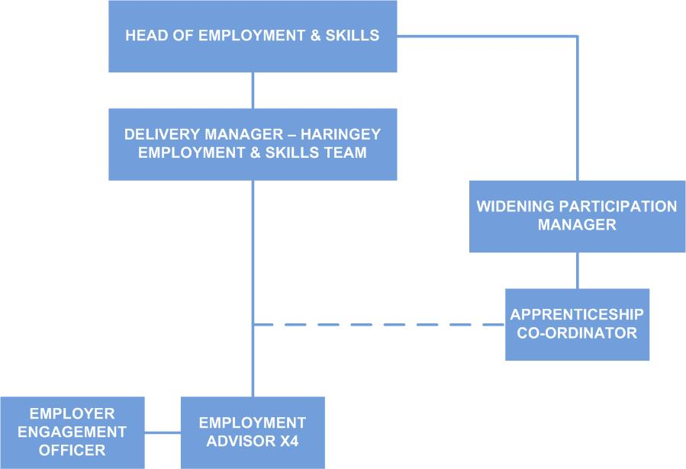

Additional Information

Please complete the additional information as fully as you can.

Supervision / Management of People
Please indicate which group best describes the total number of staff the post holder is responsible for:
None | Up to 5 staff | 6 to 15 staff | 16 to 49 staff | 50 plus staff
Are the staff based at the same work location? |  |  |  | Yes
Will the post holder be responsible for contract / agency / project staff?  The post holder will have matrix management responsibility – alongside the Delivery Manager, Haringey Employment & Skills Team – for an Apprenticeship Co-ordinator.  In addition, the post holder will be responsible for co-ordinating a number of people within and external to the local authority, some of whom may be in a more senior position than the post holder. |  |  |  | Yes

In the normal course of their duties would it be reasonable to expect the job holder to undertake, or be involved in, any of the following on a regular basis.
If Yes, please provide an estimate of the % of their working day this involves.

Work Environment
Activity | Yes/No | % of working day | Activity | Yes/No | % of working day
Office duties. | Yes | 70% | Use of a computer. | Yes | 70%
Audio typing. | Yes |  | Crisis or conflict situations.
Walking more than a mile. |  |  | Manual handling.
Working alone or in isolation. | Yes | 20% | Working in confined spaces.
Driving a car, van or minibus. |  |  | Preparing or serving food.
Exposure to infectious diseases, e.g. Tuberculosis (TB) or Hepatitis B. |  |  | Working in awkward positions, e.g. stooping, bending, reaching.
Exposure to substances hazardous to health, including lead, asbestos or radioactive substances. |  |  | Operating heavy or hazardous machinery including forklifts, diggers or cranes.
Regular and repetitive movements. |  |  | Working shifts / unsocial hours, nights.
Outdoor work involving uneven surfaces. |  |  | Standing or sitting for prolonged periods.

Activity | Yes/No | % of working day | Activity | Yes/No | % of working day
Working shifts / unsocial hours / nights. |  |  | Working at heights / on ladders, roof work.
Teaching, or responsibility for, children. |  |  | Outdoor work involving extremes of temperature.
Electrical hazards. |  |  | Control and restraint.

Resources – identify & list personal and identifiable accountability for physical and financial resources including those of clients:
Matrix management responsibility – alongside the Delivery Manager, Haringey Employment & Skills Team – for an Apprenticeship Co-ordinator.

Liaise with senior officers within the council and other services to ensure that widening participation activities are delivered in a way that maximises the benefits to residents, and that the objectives of the project are consistent with corporate priorities.

To ensure all key project outputs and milestones are closely and regularly monitored, including the performance of external partners and contractors if relevant.

Cash/Financial Resources - Is the post personally and identifiably accountable for the accurate handling / security of cash and cheques? If yes, specify the average amount controlled at any one time and the nature of the accountability:
The post holder will be responsible for managing the project budget.

The post holder will identify and apply for funding opportunities in relation to widening participation activities.

Plant/Equipment - is the post personally accountable for the proper use / safekeeping of plant / equipment? If yes, please indicate the type(s) of plant/equipment and the nature of the accountability:
N/A

Stocks/Materials - Is the post personally accountable for materials / items of stock? If yes, please indicate the type and approximate value and the nature of accountability:
N/A

Data Systems - is the post personally accountable for the use, manipulation and safekeeping of data systems whether manual or computerised? If yes please indicate the type of system(s) and the nature of the accountability, whilst explaining the importance of the data systems to the Council’s operations:
The post holder will be responsible for ensuring that personal data is collected and stored in accordance with council standards and legal requirements.

Buildings - Is the post personally accountable for the proper use and safekeeping of buildings? If yes please indicate the type of building(s) concerned and the nature of the accountability:

N/A

