Job Profile
Position Details
Post | Parks Project Officer
Service Area | Commercial and Operations/Commissioning and Client/Public Realm/Parks and Open Spaces
Reports to | Parks Development Manager
Grade | PO2
Job Family | To be completed by HR

Role Purpose
- To take responsibility for the development and delivery of allocated projects in accordance with robust project planning procedures, procurement rules, health and safety regulations and the councils financial and contract standing orders.

- To ensure that all projects are developed in conjunction with internal colleagues, residents and partners and take on board their views in developing final proposal for each project.

- To be responsible for the development of all necessary project documentation from initial scoping documents through to lesson learnt logs and benefit realisations reports.

- To bid for and secure funding from a range of sources, both internal and external, in order to take projects forward in line with agreed plans.

- To support the Park Development Manager in the development and ongoing management of an improvement programme that enables all Haringey residents to have access to vibrant inclusive green spaces.

Main Responsibilities
- To use project management processes for the scoping, approval and delivery of projects that support the delivery of the Service Business Plan and Corporate Plan

- To manage and be accountable to funders, including both the Council and external funders, for budgets and all other allocated resources in order to achieve maximum effectiveness and value for money.

- Responsible for checking and approving requests received from contractors for payment, against work carried out and agreed contract rates

- To develop, actively manage and regularly review timetables for project delivery

- To recruit and coordinate project teams including appropriate professional, technical and support staff to ensure that projects are delivered effectively and in line with agreed objectives.

- To assist the Park Development Manager in the development and implementation of a range of business/service plans.

- To work with other Council services, partners, stakeholders and funders to ensure that projects meet resident, Council, stakeholder and funder objectives.

- To actively identify and manage risk throughout the life of projects.

- To be proactive in dealing with incidents, occurrences, hazards, defects etc which may compromise the health and safety or interfere with users of the parks and open spaces.

- To develop, maintain and review procedures and working methods and ensure that these are integrated with Council systems and are effective and efficient.

- To identify, monitor, review and report on relevant KPI’s and other performance information as required.

- To prepare reports for Members, senior officers, external funders, partners and others as required.

- To communicate project progress and manage communications and PR for the project ensuring the provision of timely and relevant information in line with the project communications plan.

- To actively engage with customers, ensuring that their feedback and needs are reflected in how services are delivered.

- Investigate, analyse and respond to customer complaints, Members and MP enquiries and take appropriate action to address any procedural and operational deficiencies and ensure that lessons learned are reflected appropriately.

- To develop constructive relationships and effective communications with key people, both inside and outside the Council, that are crucial to the success of the Business Unit including colleagues, contractors, Councillors, partners and the public.

- To assist and attend meetings with other council services, corporate groups and working parties, the public, voluntary and community organizations and relevant outside bodies and statutory agencies.

- Responsible for capital and revenue budget management to include: profiling, regular monitoring, taking corrective action; effective procurement and achieving savings. Budget management should be undertaken in accordance with Council policy and procedures and any specific conditions associated with the project budget.

- Working collaboratively with Commissioning and Client colleagues to research, identify and evaluate new initiatives, operating models or good practice, and secure continuous improvement in service delivery and/or a reduction in unit costs.

- To organise the collection and reporting of performance information, contract monitoring results and customer feedback in line with council procedures and standards.

- To prepare reports and briefings on service related matters, attend meetings and advise the Councils’ Senior Officers and Members.

- Promote a ‘one Haringey’ approach.

- Ensure full compliance across your service area with appropriate legislation, Council Policies, standing orders, financial regulations and other governance requirements.

Generic Responsibilities
- Understanding, knowledge and ability to follow guidelines that ensures compliance with Health and Safety at Work, Data Protection and other statutory requirements.
- Understanding and commitment to promoting and implementing the Council’s Equal Opportunities policies.
- Knowledge and experience of using IT.
- To undertake any other temporary responsibilities aligned with the overall purpose and grade of the role.

Knowledge, Qualifications, Skills and Experience | Essential or  Desirable
3 years’ practical experience in a Parks Development Role, Parks improvement projects, Play related installations and managing small scale projects.  Extensive experience of stakeholder engagement, communication and consultation.  Ability to establish positive working relationships and to work closely with councillors, council officers, community groups, residents and contractors.  Ensure high level of service delivery, professional practice and customer care in the delivery of services. Engaging with service users, colleagues and partner organizations, to meet the priorities of the Councils Corporate Plan.  Strong planning skills including the ability to plan projects, taking account of interdependencies and conflicting demands.  Ability to write and present formal reports, collate data and information on complex issues.  Commercial awareness and business acumen, sufficiently to identify and secure new sources of income.  Experience of budget controls, delivering service plans and ensuring that costs are contained within budget.  Negotiation and influencing skills, an ability to handle tension and conflict.  An understanding and experience of working in a politically sensitive environment.  Leading and ensuring the completion of work subject to deadlines involving frequently changing circumstances and conflicting priorities.  Ability to write and present formal reports, data and information on complex issues.  Committed to the achievement of equal opportunities in both employment and service delivery.  Qualifications  A degree or equivalent, in land based industry sectors.  Knowledge/Skills  Knowledge of legislation and industry best practice, relating to Parks including; health and safety and other statutory requirements.  Ability to undertaken research and develop policy documents and statements.  Good analytical skills and ability to use data and information to inform priorities.  Demonstrates high levels of customer care and a can do attitude to getting things done.  Effective problem solving and a methodical approach.  A detailed knowledge of Haringey’s values and how they should translate into practice. | E  D  E  E  E  D  D  D  E  D  D  D  E  D  E  D  D  E  D  E

Main Contacts & Other Information
Main Contacts:

1. Lead Members and Ward Members
2. Senior Managers (DMT)
3. Partners –Homes for Haringey, The Conservation Volunteers, Woodland Trust etc.
4. Friends Groups
5. Neighbouring Local Authorities
6. External Clients (Schools, Fusion, other Housing associations

Other Information:

Cash / Financial Resources
Council Laptop and Mobile Phone.

Organisational Structure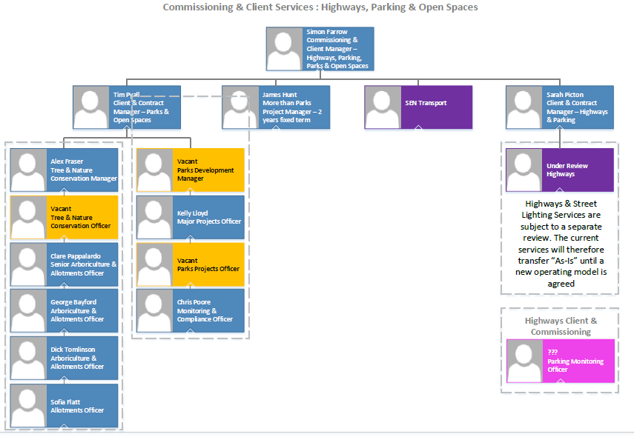

Additional Information

Please complete the additional information as fully as you can.

Supervision / Management of People
Please indicate which group best describes the total number of staff the post holder is responsible for:
None | Up to 5 staff | 6 to 15 staff | 16 to 49 staff | 50 plus staff
x
Are the staff based at the same work location? |  |  |  | N/A
Will the post holder be responsible for contract / agency / project staff? |  |  |  | No

In the normal course of their duties would it be reasonable to expect the job holder to undertake, or be involved in, any of the following on a regular basis.
If Yes, please provide an estimate of the % of their working day this involves.

Work Environment
Activity | Yes/No | % of working day | Activity | Yes/No | % of working day
Office duties. | Yes | 25 | Use of a computer. | Yes | 45
Audio typing. | No |  | Crisis or conflict situations. | No
Walking more than a mile. | Yes | 5 | Manual handling. | No
Working alone or in isolation. | Yes | 5 | Working in confined spaces. | No
Driving a car, van or minibus. | Yes | 5 | Preparing or serving food. | No
Exposure to infectious diseases, e.g. Tuberculosis (TB) or Hepatitis B. | No |  | Working in awkward positions, e.g. stooping, bending, reaching. | No
Exposure to substances hazardous to health, including lead, asbestos or radioactive substances. | No |  | Operating heavy or hazardous machinery including forklifts, diggers or cranes. | No
Regular and repetitive movements. | No |  | Working shifts / unsocial hours, nights. | No
Outdoor work involving uneven surfaces. | Yes | 5 | Standing or sitting for prolonged periods. | Yes | 10

Activity | Yes/No | % of working day | Activity | Yes/No | % of working day
Working shifts / unsocial hours / nights. | No |  | Working at heights / on ladders, roof work. | No
Teaching, or responsibility for, children. | No |  | Outdoor work involving extremes of temperature. | No
Electrical hazards. | No |  | Control and restraint. | No

Resources – identify & list personal and identifiable accountability for physical and financial resources including those of clients:
Council Laptop and Mobile Phone.

Cash/Financial Resources - Is the post personally and identifiably accountable for the accurate handling / security of cash and cheques? If yes, specify the average amount controlled at any one time and the nature of the accountability:
No

Plant/Equipment - is the post personally accountable for the proper use / safekeeping of plant / equipment? If yes, please indicate the type(s) of plant/equipment and the nature of the accountability:
No

Stocks/Materials - Is the post personally accountable for materials / items of stock? If yes, please indicate the type and approximate value and the nature of accountability:
No

Data Systems - is the post personally accountable for the use, manipulation and safekeeping of data systems whether manual or computerised? If yes please indicate the type of system(s) and the nature of the accountability, whilst explaining the importance of the data systems to the Council’s operations:
Yes – Confirm Asset Management System

Buildings - Is the post personally accountable for the proper use and safekeeping of buildings? If yes please indicate the type of building(s) concerned and the nature of the accountability:
No

