Job Profile
Position Details
Post | Physical Activity Development Officer
Service Area | Environment & Neighbourhoods/Commissioning & Client/Active Communities
Reports to | Leisure Client Contract Manager
Grade | PO1
Job Family | To be completed by HR

Role Purpose
You will focus on increasing participation in physical activity and sport across the borough with the particular objectives; to reduce health inequalities and increase community resilience. This will include: working with the community and schools to increase physical activity and sports opportunities, working to ensure sustainable sports clubs through a variety of means, developing volunteering within the physical activity and sports context. The headline KPI for the service is to increase physical activity by at least 1% per annum.

Main Responsibilities
- To manage relationships with all community and internal partners to ensure the ongoing sustainable development of physical activity and sport in the borough;
- To develop projects with partners to provide worthwhile physical activity and sports opportunities to residents which support the Council’s corporate priorities and will attract external funding/support;
- To deliver specific projects to increase physical activity and sports opportunities e.g. Parks Activation
- Work with appropriate partners, for example the leisure centre operator and tenants of park facilities to promote and develop local multi-sport activity centres;
- To develop effective working relationships with officers across all services throughout the council and with external agencies, including Fusion, Sports’ National Governing Bodies, Regional Development Officers, Public Health, Youth and Children Services, (including schools);
- Lead and nurture relationships to enable partners and stakeholders to provide physical activity and sports opportunities;
- Provide advice to community and internal partners in a timely and cost effective manner e.g. regular newsletter, website etc;
- To assist in the development of physical activity and sport policy;
- To lead and enable community events which will contribute to increases in physical activity;
- Provide support and leadership to sports clubs to increase participation, improve accessibility and nurture volunteers;
- In line with strategic aims and generally in partnership identify and develop programmes of sport and physical activity;
- Develop small budgets and seek external funding for programmes of activity and ensure overall budgetary control of these programmes;
- To collect and analyse data as and when required;
- To carry out research around physical activity and sport and effectively transfer findings to a Haringey context;
- To develop and implement administration systems;
- To work as part of a team to deliver the business and service’s key performance indicators and outcomes;
- To develop own skills and capabilities through performance appraisals, including participation in assessment and review of competencies, setting and monitoring of progress on objectives and personal development plans.

Generic Responsibilities
- Understanding, knowledge and ability to follow guidelines that ensures compliance with Health and Safety at Work, Data Protection and other statutory requirements.
- Understanding and commitment to promoting and implementing the Council’s Equal Opportunities policies.
- Knowledge and experience of using IT.
- To undertake any other temporary responsibilities aligned with the overall purpose and grade of the role.

Knowledge, Qualifications, Skills and Experience | Essential or  Desirable
- A minimum of 3 years experience in leisure or a related field;  - Ability to work unsocial hours including evenings, weekends, and bank holidays;  - Good IT skills;  - Ability to produce written reports to a good standard and generally good communication skills:  - Ability to develop and maintain effective working relationships with a range of agencies/partner services (including internal partners) to develop physical activity and sport:  - Experience at consulting with community groups;  - Ability to act as an advocate for increasing physical activity levels amongst residents;  - Experience at promoting/marketing sport and physical activity programmes;  - Ability to work under pressure and meet deadlines;  - Effective verbal, written and electronic communication skills;  - Ability to secure external funding and be responsible for monitoring arrangements;  - Ability to manage small budgets;  - Ability to negotiate with a range of partners including suppliers of physical activity services;  - Ability to work on own initiative;  - Ability to adhere to systems of performance monitoring and management;  - Ability to prioritise effectively when faced with competing demands on time;  - Ability to ensure that equalities are mainstreamed into all aspects of service delivery;  - Knowledge of Quest, National Benchmarking and other leisure quality systems;  - Knowledge of asset transfer related to sports and parks facilities;  - Understanding of health inequalities and the relationship to physical activity;  - Coaching qualifications;  - Educated at Degree Level;  - Knowledge of avenues for funding;  - Knowledge of formal project management processes  - Understanding of the monitoring of Leisure programmes and Contracts and/or Service Level Agreements.  - Knowledge of Health and Safety legislation in relation to the delivery of sport  - Good customer care skills  - Able to create and initiate new ideas  - Chairing of meetings skills  - Policy development skills  - Leadership, negotiation and persuasion skills | E  E  E  E  E  E  E  E  E  E  E  E  E  E  E  E  E  D  D  D  D  D  E  E  E  E  E  E  E  E  E  E

Main Contacts & Other Information
Main Contacts:
Active Communities colleagues;
Environment and Neighbourhoods colleagues;
Public Health;
Children and Young Peoples Service;
London Sport;
Local sports clubs and sports providers;
Leisure Centre staff;
National Governing Bodies of Sport;
Community and voluntary groups.

Other Information:

Organisational Structure
Please provide organisation structure chart.

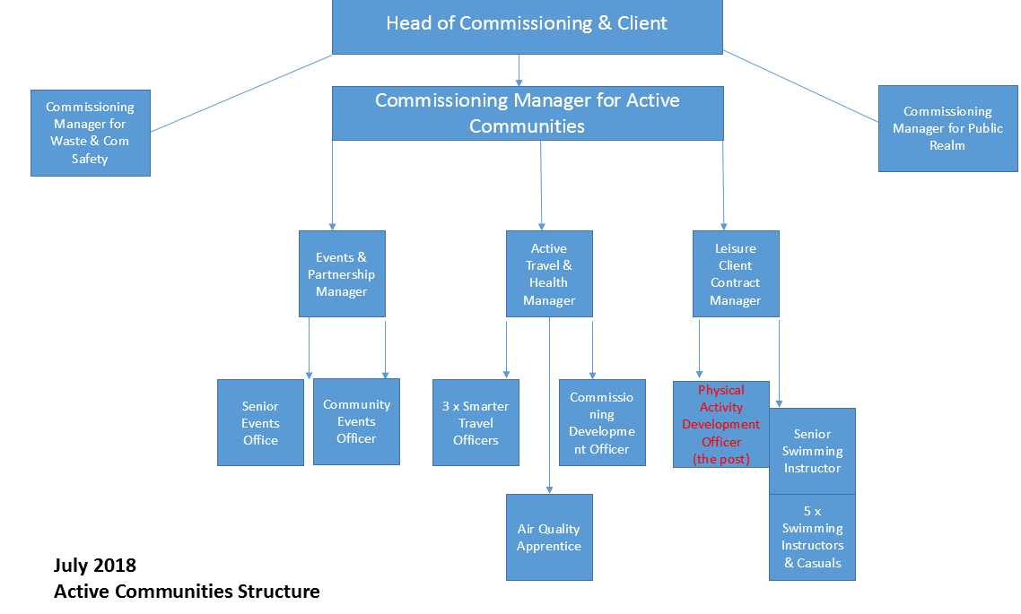
Additional Information

Please complete the additional information as fully as you can.

Supervision / Management of People
Please indicate which group best describes the total number of staff the post holder is responsible for:
None | Up to 5 staff | 6 to 15 staff | 16 to 49 staff | 50 plus staff
x
Are the staff based at the same work location? |  |  |  | NA
Will the post holder be responsible for contract / agency / project staff? |  |  |  | No

In the normal course of their duties would it be reasonable to expect the job holder to undertake, or be involved in, any of the following on a regular basis.
If Yes, please provide an estimate of the % of their working day this involves.

Work Environment
Activity | Yes/No | % of working day | Activity | Yes/No | % of working day
Office duties. | Yes | 50% | Use of a computer. | Yes | 75%
Audio typing. | No |  | Crisis or conflict situations. | No
Walking more than a mile. | Yes | 5% | Manual handling. | No
Working alone or in isolation. | Yes | 5% | Working in confined spaces. | No
Driving a car, van or minibus. | No |  | Preparing or serving food. | No
Exposure to infectious diseases, e.g. Tuberculosis (TB) or Hepatitis B. | No |  | Working in awkward positions, e.g. stooping, bending, reaching. | No
Exposure to substances hazardous to health, including lead, asbestos or radioactive substances. | No |  | Operating heavy or hazardous machinery including forklifts, diggers or cranes. | No
Regular and repetitive movements. | No |  | Working shifts / unsocial hours, nights. | Yes | 10%
Outdoor work involving uneven surfaces. | Yes | 5% | Standing or sitting for prolonged periods. | No

Activity | Yes/No | % of working day | Activity | Yes/No | % of working day
Working shifts / unsocial hours / nights. | Yes | 10% | Working at heights / on ladders, roof work. | No
Teaching, or responsibility for, children. | No |  | Outdoor work involving extremes of temperature. | No
Electrical hazards. | No |  | Control and restraint. | No

Resources – identify & list personal and identifiable accountability for physical and financial resources including those of clients:

Cash/Financial Resources - Is the post personally and identifiably accountable for the accurate handling / security of cash and cheques? If yes, specify the average amount controlled at any one time and the nature of the accountability:
No

Plant/Equipment - is the post personally accountable for the proper use / safekeeping of plant / equipment? If yes, please indicate the type(s) of plant/equipment and the nature of the accountability:
Lap top and mobile phone

Stocks/Materials - Is the post personally accountable for materials / items of stock? If yes, please indicate the type and approximate value and the nature of accountability:
No

Data Systems - is the post personally accountable for the use, manipulation and safekeeping of data systems whether manual or computerised? If yes please indicate the type of system(s) and the nature of the accountability, whilst explaining the importance of the data systems to the Council’s operations:
No

Buildings - Is the post personally accountable for the proper use and safekeeping of buildings? If yes please indicate the type of building(s) concerned and the nature of the accountability:

No

