Job Profile
Position Details
Post | Highway Inspector
Service Area | Commercial & Operations/Operations/Sustainable Transport/Highways Safety Inspections
Reports to | Highway Inspection Team Leader
Grade | S01
Job Family | To be completed by HR

Role Purpose
The post holder will be responsible for all inspection activities related to the Highways Service. This will include carrying out a regular programme of inspections within a specified area; checking the quality and quantity of works being carried out by contractors and ensuring accuracy of invoices submitted for payment.

Main Responsibilities
- You will be expected to work within assigned neighbourhood areas and provide cover in other neighbourhoods when necessary
- To inspect streets, logging and reporting defects on assets such as street furniture, carriageway surfaces and road gullies and raising jobs as necessary.
- To investigate reports of defects and complaints received from the public and other sources and raising remedial works where necessary.
- When insurance claims are received, to inspect the site concerned and prepare a report and discuss the claim with insurance representative and attend court as necessary.
- To act as the “Eyes and Ears” for the Council, ensuring that any matters affecting customer perception identified during inspections are referred to the appropriate team or Business Unit within the Council.
- To inspect all road closure gates on the public highway and replacing as necessary broken or missing padlocks, and reporting any other defects to the Team Leader.
- To use computer and hand held devices to support the delivery of reactive maintenance utilising the council’s highway asset management system, GIS and other appropriate software
- To ensure prompt and clear responses to all forms of communications including complaints, e-mails, telephone calls and letters, from members of the public, Councillors, MPs, and other organisations.
- Ensuring that where, during routine maintenance inspections, works by Utilities are identified, of which the Council have not been notified, relevant information is passed to the network team
- To ensure all defects are priced correctly using the appropriate schedule of rate items.
- To ensure all inspections are undertaken within the correct timescales to the appropriate standards as current council policy and guidelines.
- To be proactive in dealing with incidents, occurrences, hazards, defects etc which may compromise the health and safety or interfere with users of the public highway.
- To ensure that all gully cleansing work is completed to the required specification by the Council's contractor checking worksheets and inputting relevant data.
- To be responsible for providing performance management reports on highways activities within a specified Neighbourhood Area.
- To adhere to all council procedures including the council’s constitution and decision making; financial procedures; standing orders; procurement; health and safety; public consultation; performance management; complaints, communication and consultation.
- To develop constructive relationships and effective communications with key people, both inside and outside the Council, including colleagues, contractors, councillors, partners and the public.
- To represent Haringey Council in a professional manner at all times.
- To deputise for the Highway Inspection Team Manager as and when needed.

Generic Responsibilities
- Understanding, knowledge and ability to follow guidelines that ensures compliance with Health and Safety at Work, Data Protection and other statutory requirements.
- Understanding and commitment to promoting and implementing the Council’s Equal Opportunities policies.
- Knowledge and experience of using IT.
- To undertake any other temporary responsibilities aligned with the overall purpose and grade of the role.
- To undertake other duties consistent with the basic objectives and/or duties of the post.

Knowledge, Qualifications, Skills and Experience | Essential or  Desirable
Achieve a pass grade on the city and guilds Highway safety inspection course – 6033, unit 301/311 | Desirable & Essential to achieve within 1 year of employment.

Main Contacts & Other Information
Main Contacts:

Sam Swales – 0208 489 4594

Other Information:

This position requires the postholder to undergo a DBS (Disclosure and Barring Service) check.

From time to time weekend and out of hours work (including attending meetings) may be required. The appropriate time off in lieu arrangements will apply.

Organisational Structure
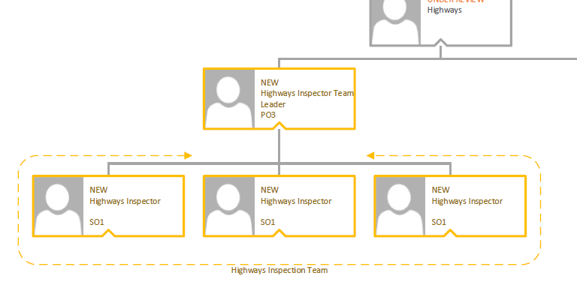

Additional Information

Please complete the additional information as fully as you can.

Supervision / Management of People
Please indicate which group best describes the total number of staff the post holder is responsible for:
None | Up to 5 staff | 6 to 15 staff | 16 to 49 staff | 50 plus staff
Are the staff based at the same work location? |  |  |  | N/A
Will the post holder be responsible for contract / agency / project staff? |  |  |  | N/A

In the normal course of their duties would it be reasonable to expect the job holder to undertake, or be involved in, any of the following on a regular basis.
If Yes, please provide an estimate of the % of their working day this involves.

Work Environment
Activity | Yes/No | % of working day | Activity | Yes/No | % of working day
Office duties. | Yes | 10 | Use of a computer. | Yes | 10
Audio typing. | No |  | Crisis or conflict situations. | No
Walking more than a mile. | Yes | 90 | Manual handling. | No
Working alone or in isolation. | Yes | 90 | Working in confined spaces. | No
Driving a car, van or minibus. | Yes | 10 | Preparing or serving food. | No
Exposure to infectious diseases, e.g. Tuberculosis (TB) or Hepatitis B. | No |  | Working in awkward positions, e.g. stooping, bending, reaching. | No
Exposure to substances hazardous to health, including lead, asbestos or radioactive substances. | No |  | Operating heavy or hazardous machinery including forklifts, diggers or cranes. | No
Regular and repetitive movements. | No |  | Working shifts / unsocial hours, nights. | No
Outdoor work involving uneven surfaces. | Yes | 1 | Standing or sitting for prolonged periods. | No

Activity | Yes/No | % of working day | Activity | Yes/No | % of working day
Working shifts / unsocial hours / nights. | No |  | Working at heights / on ladders, roof work. | No
Teaching, or responsibility for, children. | No |  | Outdoor work involving extremes of temperature. | No
Electrical hazards. | No |  | Control and restraint. | No

Resources – identify & list personal and identifiable accountability for physical and financial resources including those of clients:

Cash/Financial Resources - Is the post personally and identifiably accountable for the accurate handling / security of cash and cheques? If yes, specify the average amount controlled at any one time and the nature of the accountability:
No

Plant/Equipment - is the post personally accountable for the proper use / safekeeping of plant / equipment? If yes, please indicate the type(s) of plant/equipment and the nature of the accountability:
No

Stocks/Materials - Is the post personally accountable for materials / items of stock? If yes, please indicate the type and approximate value and the nature of accountability:
No

Data Systems - is the post personally accountable for the use, manipulation and safekeeping of data systems whether manual or computerised? If yes please indicate the type of system(s) and the nature of the accountability, whilst explaining the importance of the data systems to the Council’s operations:
Yes, computerised. Highways Asset Management System CONFIRM. CONFIRM is integral to everything we do with highways inspections and is vital to be kept up to date in order to maintain the Council’s Section 58 defence.

Buildings - Is the post personally accountable for the proper use and safekeeping of buildings? If yes please indicate the type of building(s) concerned and the nature of the accountability:

No

